Air Flow Sensor

One of the parameters that need to be measured is the air speed within the green house. To measure this a sensor circuit must be designed. In this document the choice for the type of sensor will be discussed and chosen.

# Requirements

To choose the right sensor, the sensor must meet certain requirements. These requirement are the following:

Air Speed: The sensor must be capable of measuring air speeds of 0,25 m/s with an accuracy of 0.03m/s

Power: The power consumption must be as low as possible. This is because the nodes are working on a battery. This can be determined later with the type of sensor

Costs: Due to a limited budget, the sensors must be as low-cost as possible.

# Sensors

After the requirements are determined the sensor can be chosen. The following types of sensor will be looked at and compared via a morphological table. The sensors are:

* Ultrasonic Anemometer
* Thermal Anemometers
* Tube Anemometers

## Ultrasonic Anemometer

The first sensor is the ultrasonic anemometer. This is a sensor that uses the principle of ultrasound to measure wind speed. They measure wind speed based on the time of flight of sonic pulses between pairs of [transducers](https://en.wikipedia.org/wiki/Transducer). Measurements from pairs of transducers can be combined to yield a measurement of velocity in 1-, 2-, or 3-dimensional flow.

## Thermal Anemometer

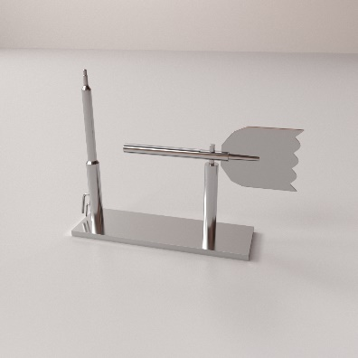Hot wire anemometers use a fine wire electrically heated to some temperature above the ambient. Air flowing past the wire cools the wire. As the electrical resistance of most metals is dependent upon the temperature of the metal, a relationship can be obtained between the resistance of the wire and the flow speed. One of the requirements of this sensor is that one of the power parameters are constant( Voltage, Current). The sensor uses an PT100 to measure the temperature changes.

## Tube Anemometers

If the wind blows into the mouth of a tube it causes an increase of pressure on one side of the manometer. The wind over the open end of a vertical tube causes little change in pressure on the other side of the manometer. The resulting elevation difference in the two legs of the U tube is an indication of the wind speed.

# Morphological Table

|  |  |  |  |  |
| --- | --- | --- | --- | --- |
| Requirement | Weighing Factor (0-5) | Ultrasonic | Thermal | Tube |
| Air Speed | 5 | 3 | 5 | 1 |
| Costs | 2 | 4 | 5 | 1 |
| Total |  | 23 | 35 | 7 |

## Ultrasonic

**Air Speed:**

Minimum air speed of around 0.01m/s with an accuracy of 0.1m/s.

**Costs:**

This can be done with the SRF ultrasound sensor. These are around 5 euros at it cheapest.

## Thermal

**Air Speed:**

Minimum air speed of 0m/s and accuracies up to 0.015m/s.

**Costs:**

Since the circuit mainly exist of an PT100 with some resistors the costs will never be high.

## Tube

**Air Speed:**

Minimum air speed of 1m/s with an accuracy of 0.3%(0.003m/s).

**Costs:**

The cheapest versions of a pitot tube are around 20 euros.

From this morphological table it is clear that the thermal anemometer is the best to use in the nodes of the Plantenna project,

# Thermal Anemometer

Now the type of sensor is chosen the right specific sensor has to be chosen. This will be done in the same way as with the type of sensor, via a morphological table. Two different sensors will be compared and eventually one will be chosen to measure the air flow. The 2 sensor that will be compared are:

* Wind Sensor Rev. C
* Wind Sensor Rev. P

Both sensor are from the same company but both have their advantages and disadvantages. The sensors make use of a technique called the hot wire technique. With this a hot wire will be heated and the temperature of the wire will be measured. Whenever there is wind the wire will cool down and the temperature measure will change. With this the air speed can be measured.

To compare these 2 sensors, the sensor will me graded at the following requirements:

* Power Consumption
* Operating Voltage
* Output Voltage Range
* Cost

These are the following specifications for each requirement

|  |  |  |
| --- | --- | --- |
|  | Rev. C | Rev. P |
| Power Consumption | 0.2W (max) | 0.48W(max) |
| Operating Voltage | 4-5V | 9-12V |
| Output Voltage Range | 0-5V | 0-3.3V |
| Cost | €17.50 | €24.50 |

### Getting Started

## Requirements:

* Segger Embedded Studio for ARM 4.52c or newer needs to be installed.
* nRF5_SDK_16.0.0_98a08e2.zip needs to be unzipped on the local drive. (Can be found on the OneDrive, Folder: “Spring_2020_S6_IPD -> Modules -> Nodes -> Air Flow)
* Putty

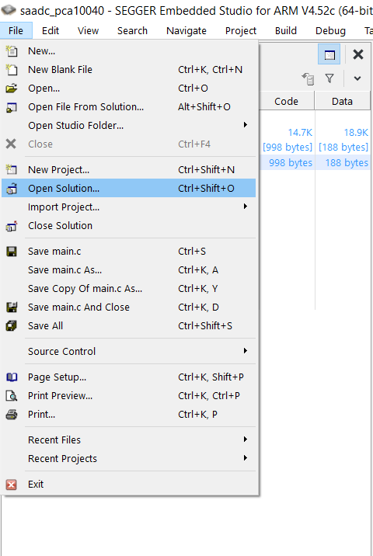To make the sensor work like it is supposed to do the code in the NRF52 library “saadc” need to be adjusted. To do this, open “Segger Embedded Studio for ARM”. When the program is opened click on “File -> Open Solution…”.

Search for the nRF5_SDK_16.0.0_98a08e2 folder on your local drive.

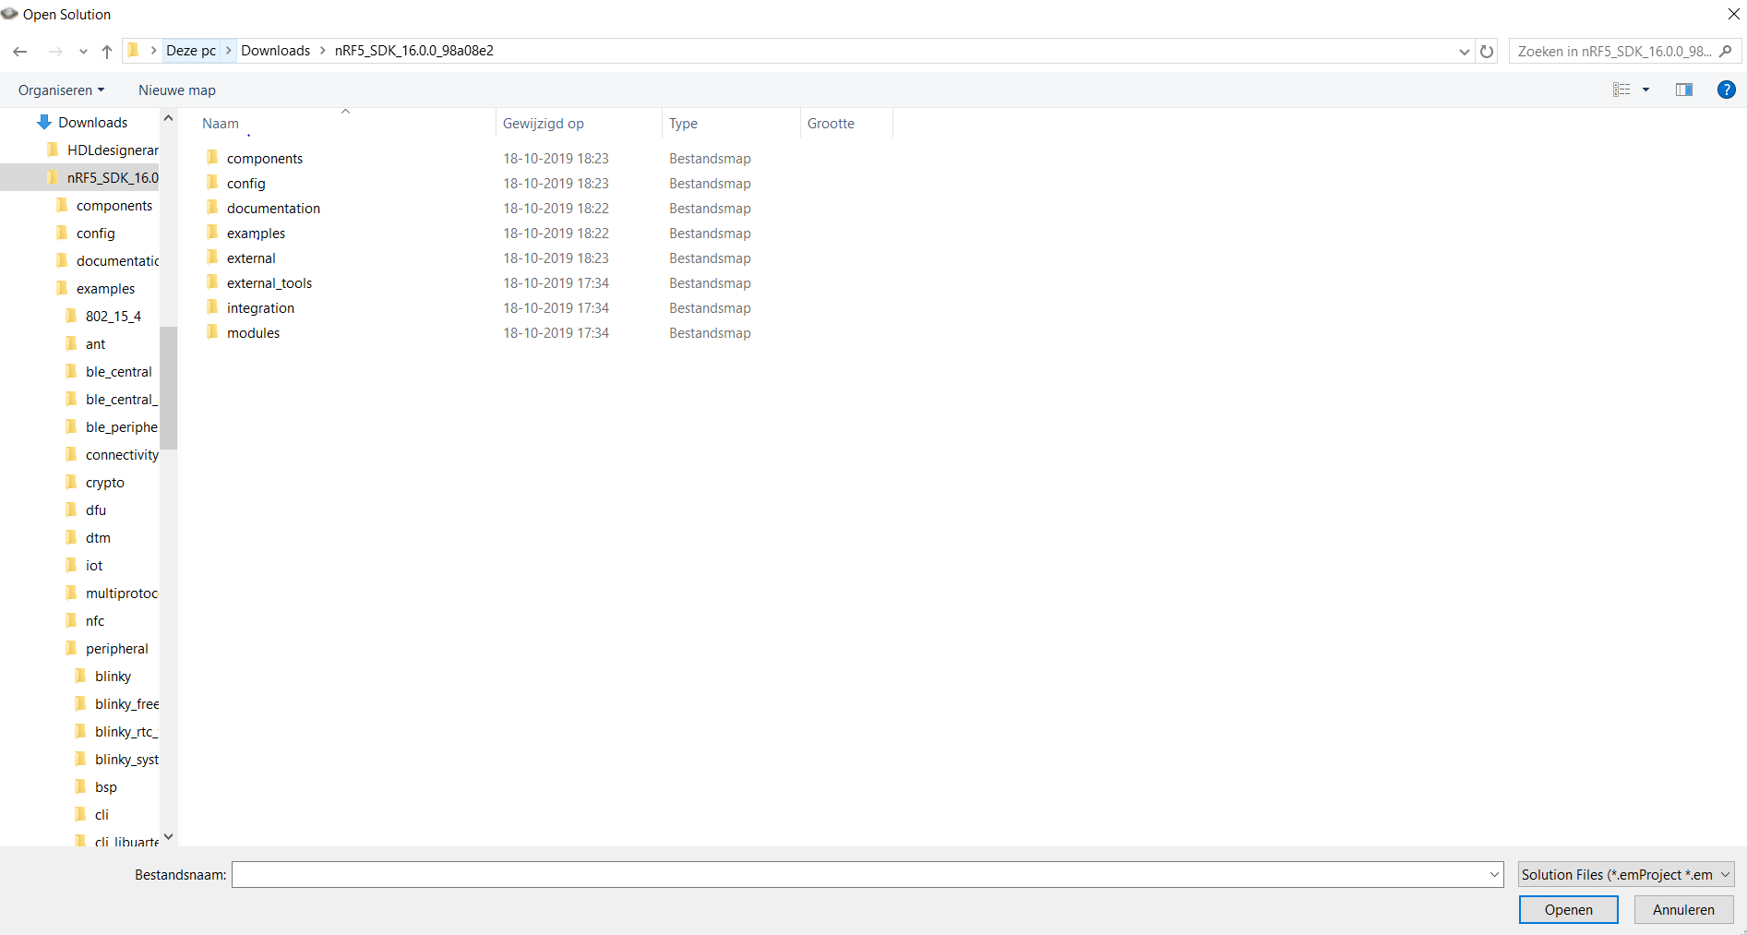

Open the folder “examples -> peripheral -> saadc -> pca10040 -> blank -> ses”

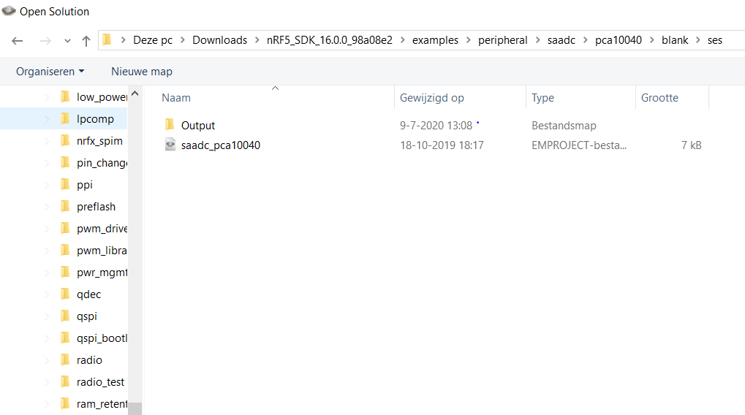

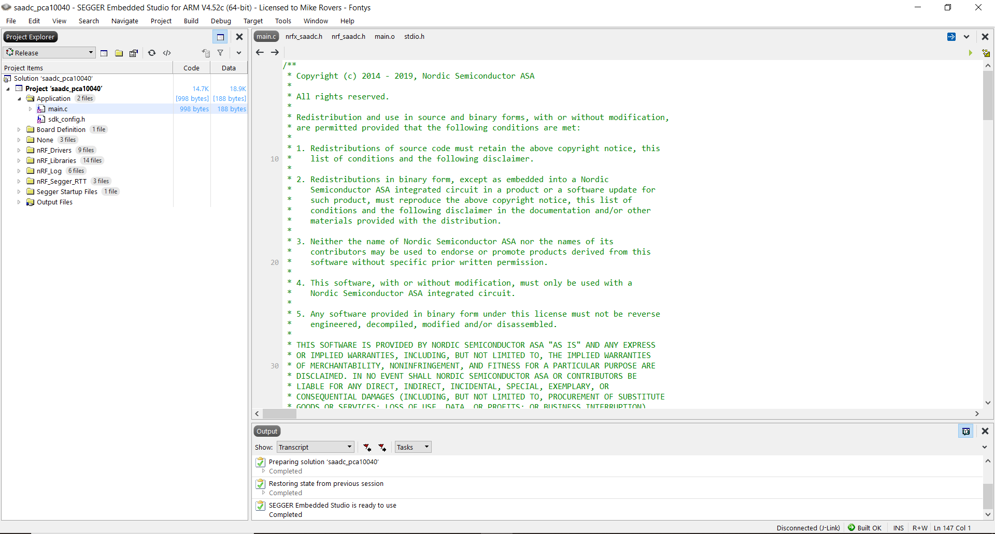Here you can find the file: “saadc_pca10040”. Open the file by double clicking on the file or press Open. If done correct, the following screen will appear:

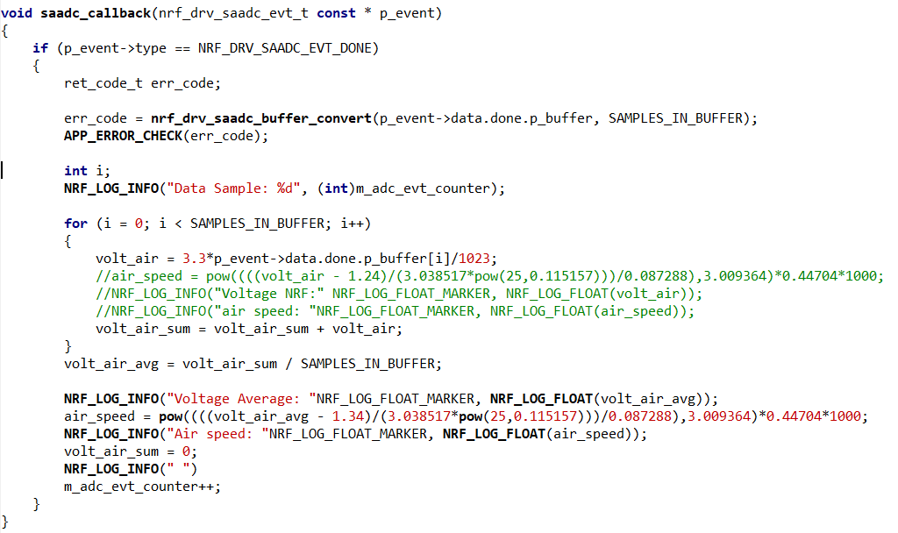Now the code is ready to be adjusted. To do this, find the function “**saadc_callback**” and go to “**main.c**”. Within this function the code must be adjusted. After adjusting it the code should look as follows:

In order to make this function fully functional, some variables need to be determined at the top. The variables are the following:

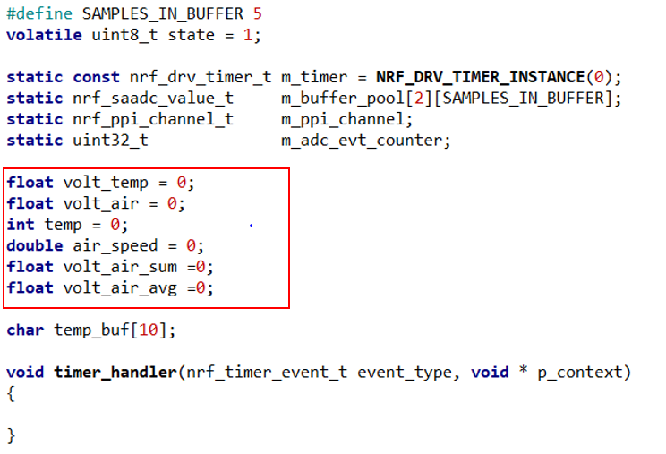

If these steps are done, it is time to calibrate the sensor. To do this first the code needs to be uploaded to the nRF52. To do this go to “**Build -> Build and Run**”.

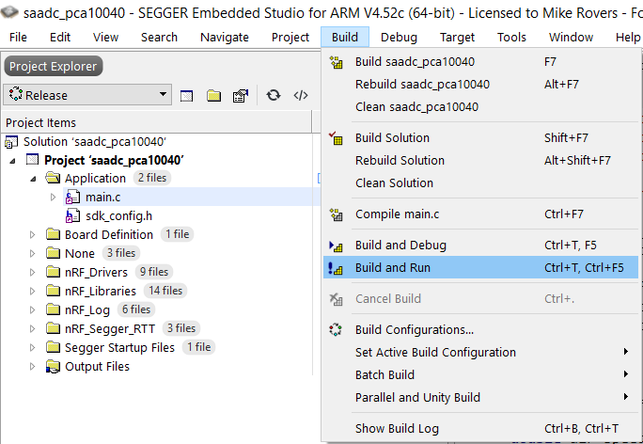

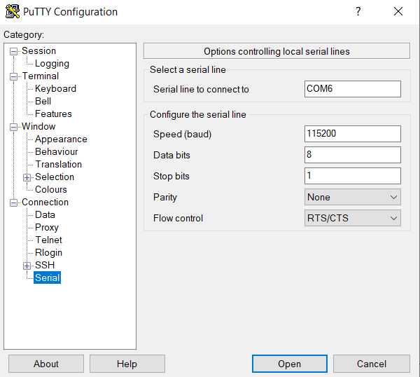After this is done, open Putty to see the results of the sensor. When started Putty, the first thing to do is to set up Putty in the correct way. The settings in Putty are the following:

Notice that the COM port might vary, since this depends on your device. After everything is set press Open.

Now the results of the sensor will be shown within Putty. Now it is time to calibrate the sensor so it can be used properly. To do this, place a cup above the sensor. This is done, because the voltage needs to be measured when there is no wind. Write down the voltage given by the value in Putty. This value will be used in the code adjusted earlier.

Go back to the “**saadc_callback**” function. Change the value marked with red in the picture below and replace it with the voltage measured when the air speed is 0mm/s.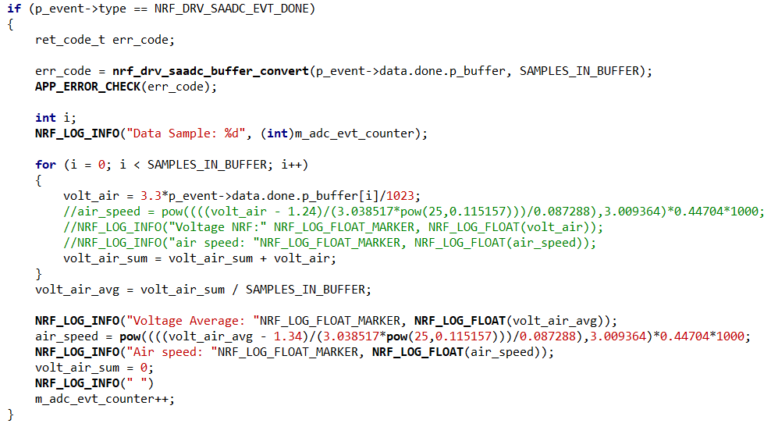

Now the sensor is ready to be used for the node and further tests.